eCMS MANUAL

PASSENGER MANIFEST

Department of Revenue and Customs
Ministry of Finance
Table of Contents
1. Logging In Custom User: 1
2. Approve Declaration 1
2.1. Search Declaration: 1
2.2. Approve Declaration 2
2.3. Search and Approve Amendment 3
2.4. Search and Approve Cancellation 3
2.5. Create Declaration 4
3. Valuation 4
4. Centralized Risk 5
5. Gate in Pass 6
6. Release Order 6

Logging In Airlines:

- The user needs to log into eCMS using the url: www.ecms.gov.bt
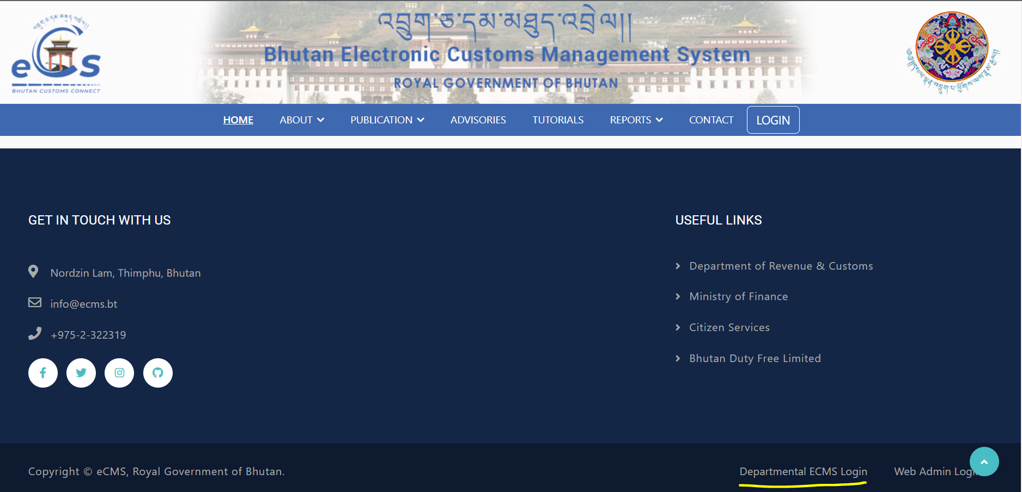
- Click on login menu and provide the required credentials to log in to the system:
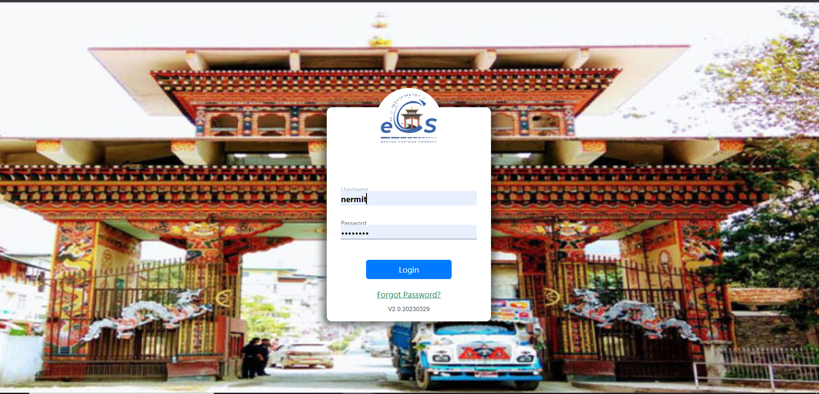

Create Passenger Manifest
- Select passenger manifest from the list of menus provided in the dashboard:
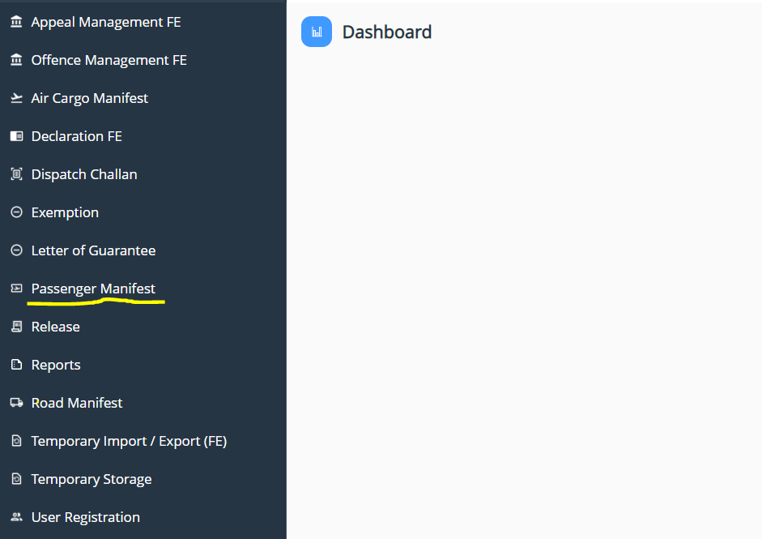
- Under the Passenger Manifest menu, Select Create Passenger manifest:
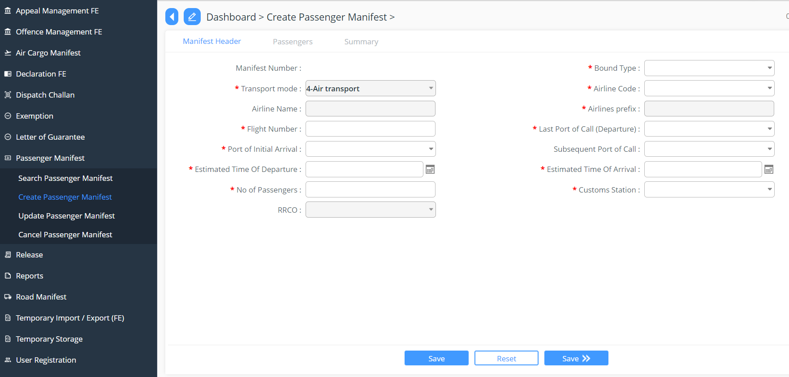

- Key in the details under each menu provided:

  - Manifest header: here need to provide the details of the flight and no of passenger details, filling in all the required


  - Passengers: add in the details of the crew/ passenger for the manifest
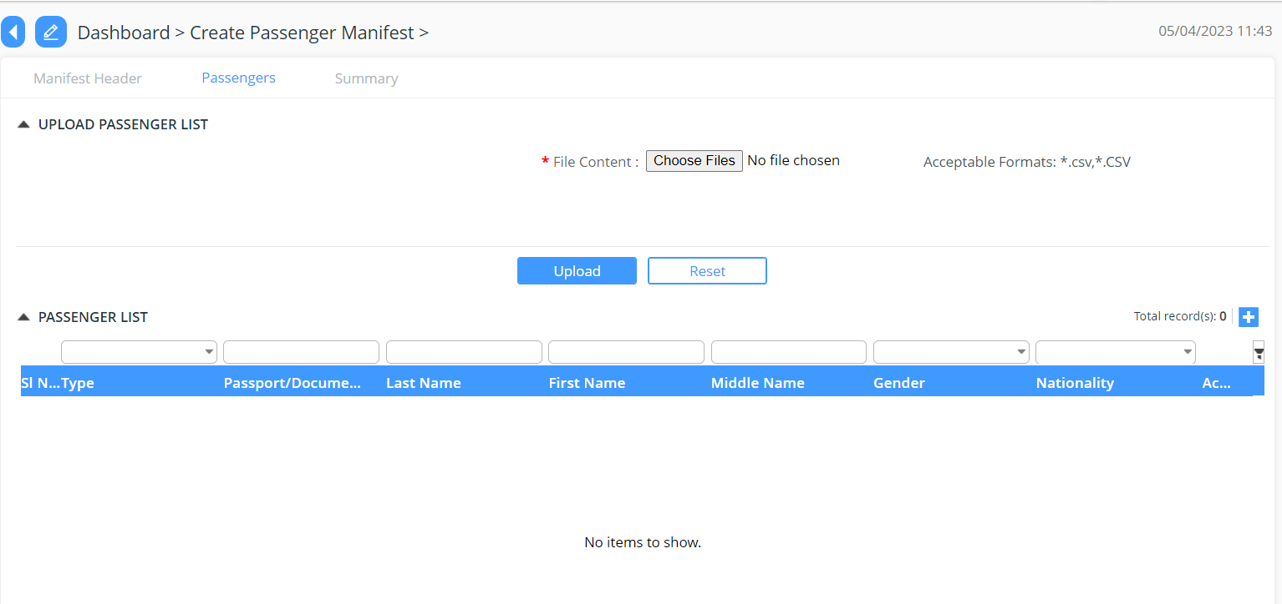
  - Summary: provide the summarized details of the detailed filed in for passenger manifest
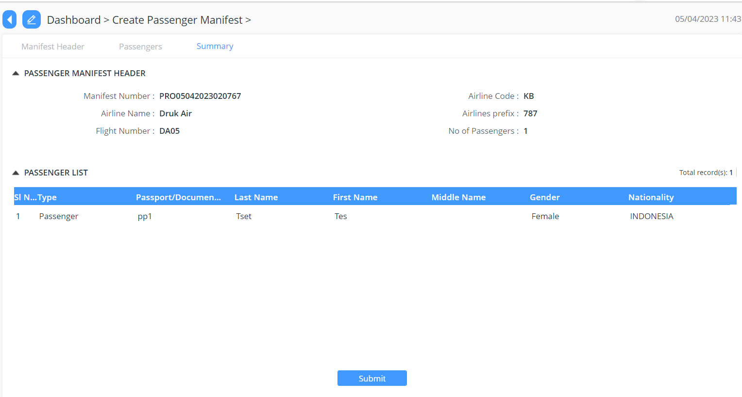

Track Application
- An application Number will be Generated:

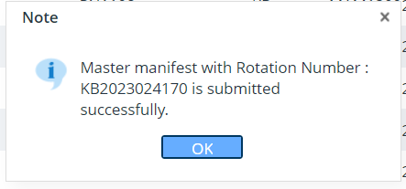

- The users will be able to track their application from search passenger manifest:

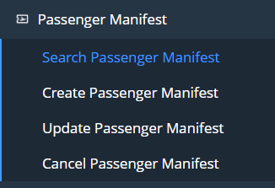

Update and Cancel Passenger Manifest
- The created and submitted passenger manifest can be updated or cancelled by providing the valid reasons.
- Click onto Update Passenger Manifest for update of the manifest
- Click onto Cancel Passenger Manifest for cancellation of the manifest

